Installation Failure Analysis
- Percentage distribution of failure rate over all possible causes:
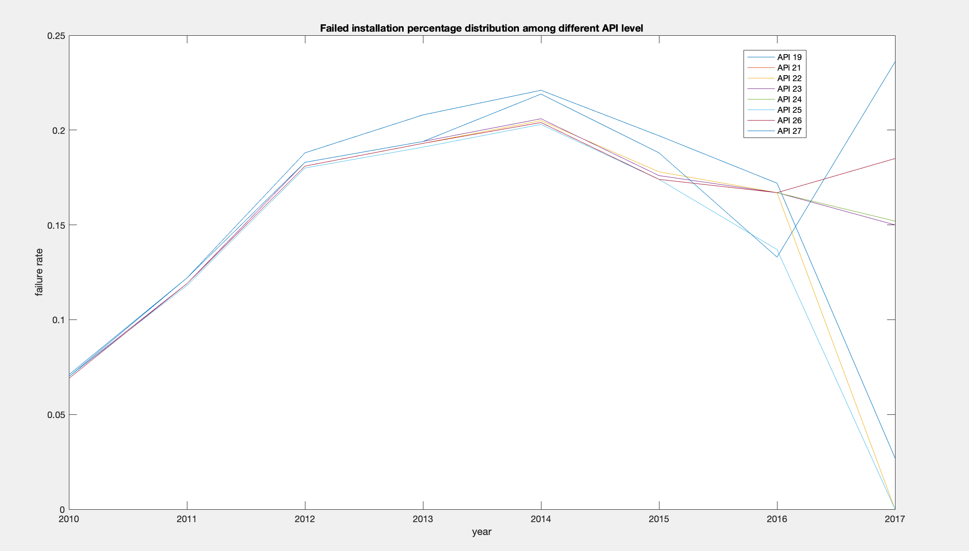
Failed installation percentage distribution among different API level.fig

- For aggregate failure rate, concerning (failure rate, SDK release year - app develop year, SDK API level - app minimum API level)
  - Distribution figure (3D)
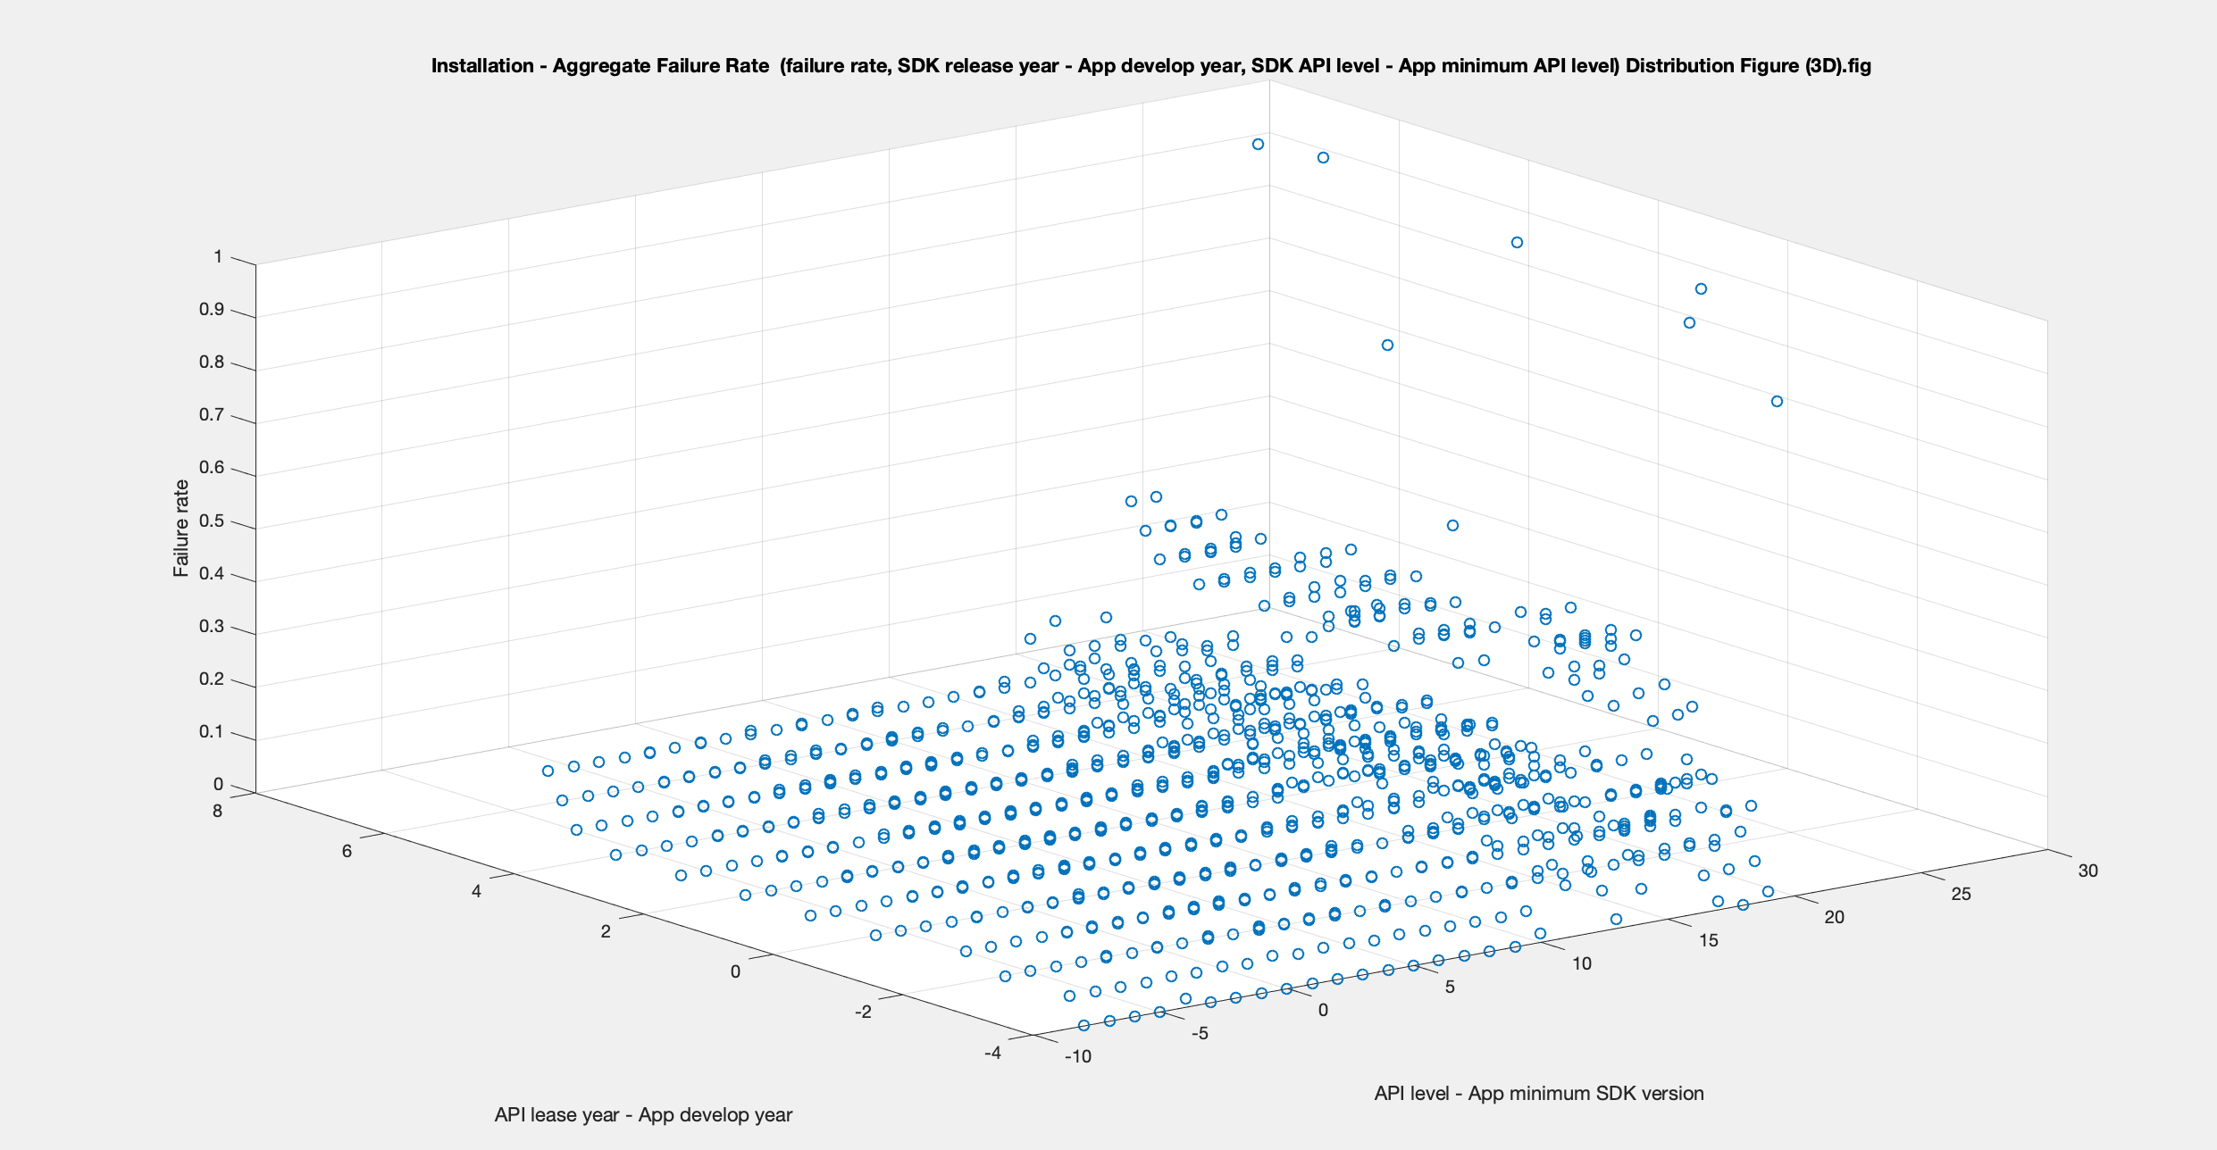
Figure: Installation - Aggregate Failure Rate (failure rate, SDK release year - App develop year, SDK API level - App minimum API level) Distribution Figure (3D).fig
  - Correlation analysis (non-parametric)-
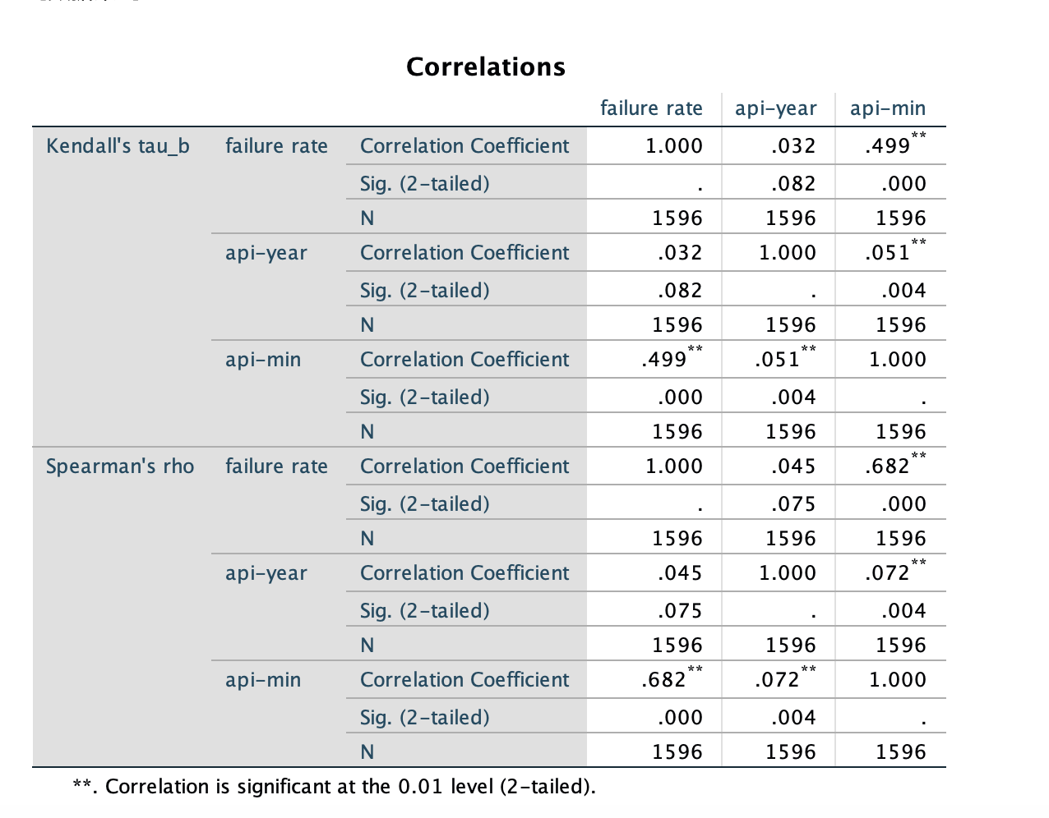
For correlationships:
0.0 - 0.2 very weak
0.2 - 0.4 weak
0.4 - 0.6 moderate
0.6 - 0.8 strong
0.8 - 1.0 very strong

- For major (top)-cause failure rate, concerning (failure rate, SDK release year - app develop year, SDK API level - app minimum API level)
  - Distribution figure (3D)
    - INSTALL_FAILED_NO_MATCHING_ABIS
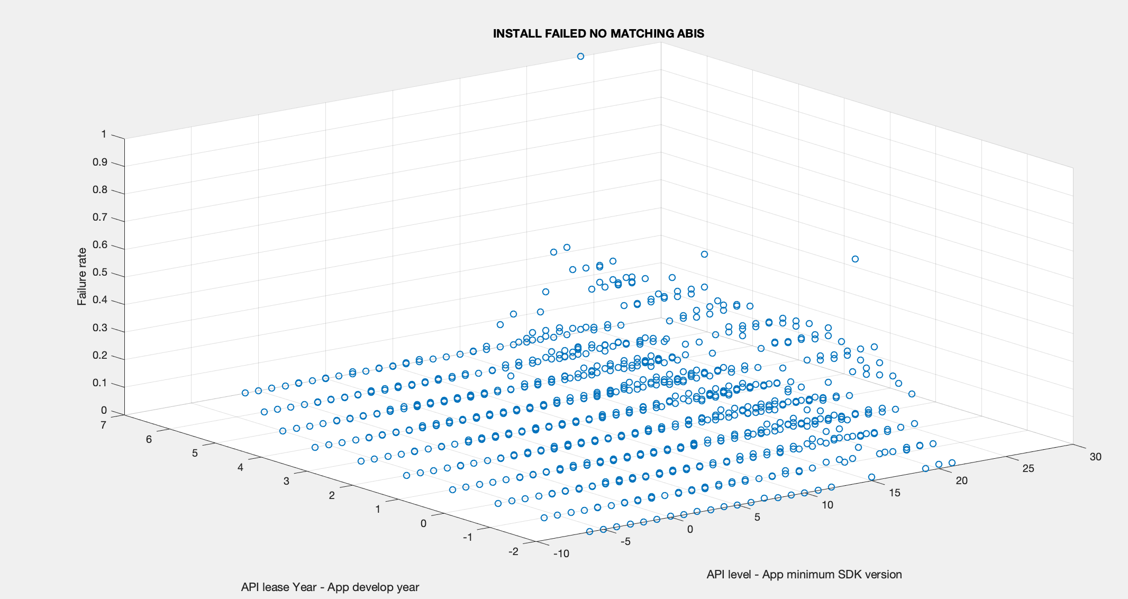

    - INSTALL_FAILED_MISSING_SHARED_LIBRARY
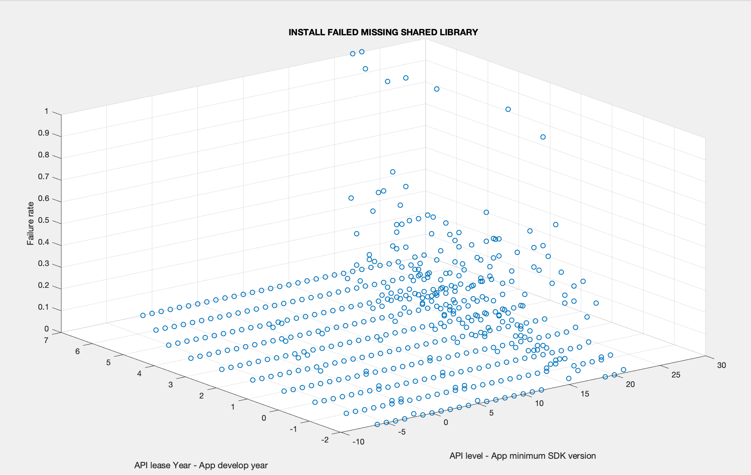

  - Correlation analysis (non-parametric)
    - INSTALL_FAILED_NO_MATCHING_ABIS
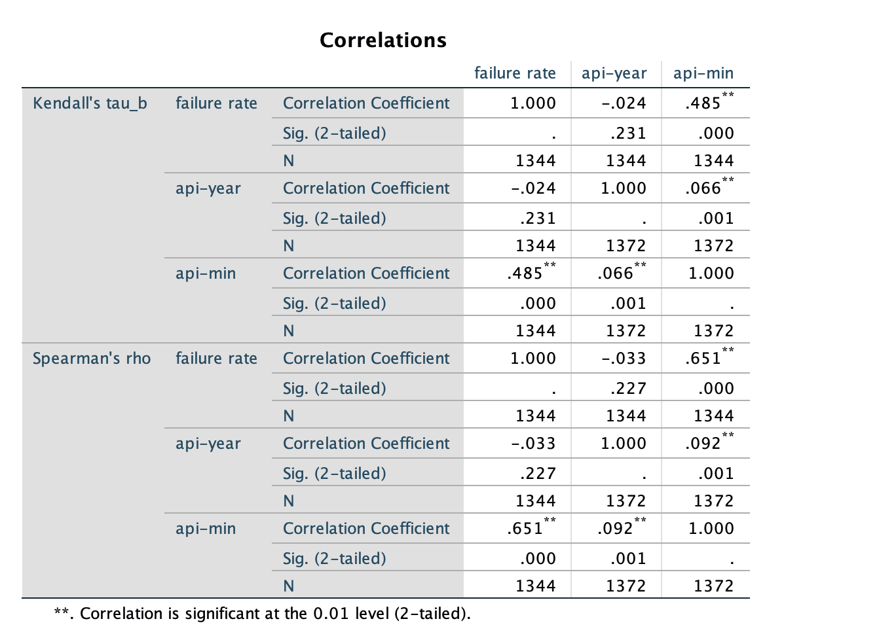
    - INSTALL_FAILED_MISSING_SHARED_LIBRARY

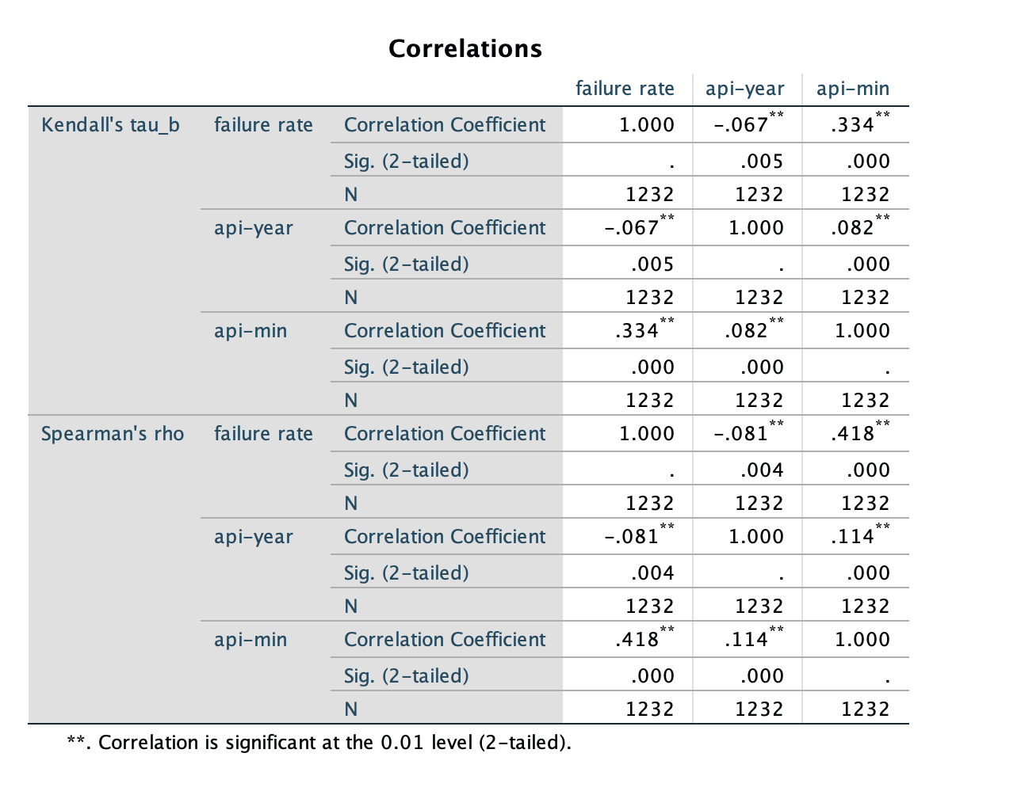

- For aggregate failure rate, concerning (failure rate, SDK API level, app minimum API level, app year)
  - correlation analysis (non-parametric)
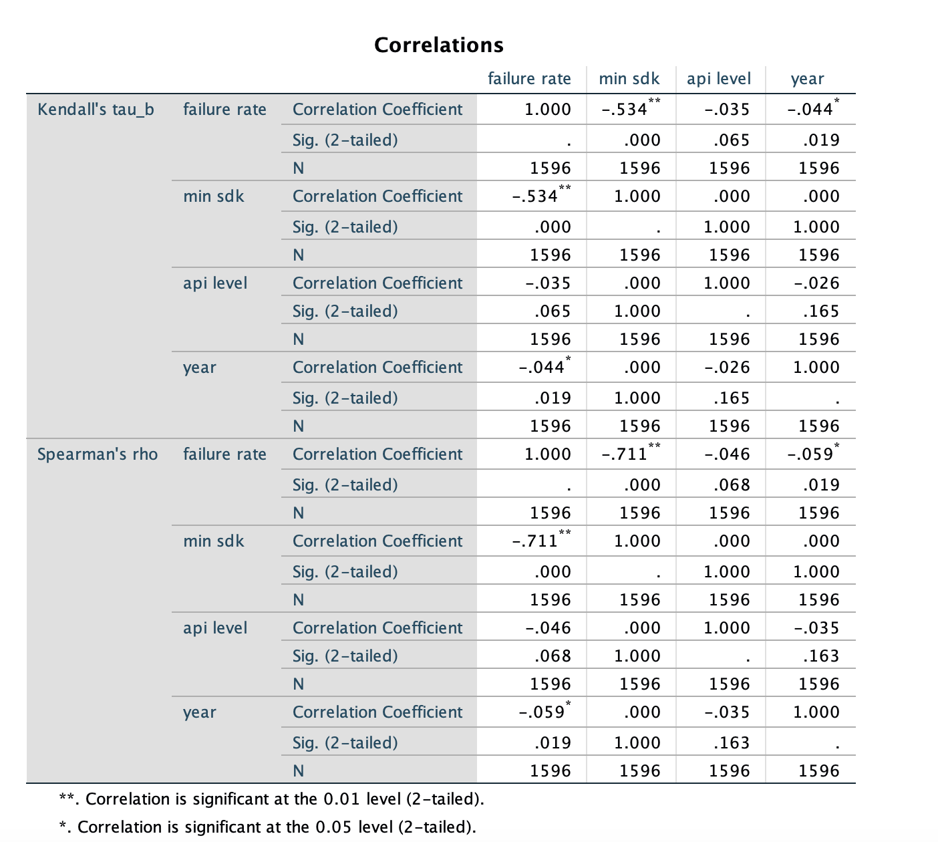
- For major (top)-cause failure rate, concerning (failure rate, SDK API level, app minimum API level, app year)
  - correlation analysis (non-parametric)
    - INSTALL_FAILED_NO_MATCHING_ABIS
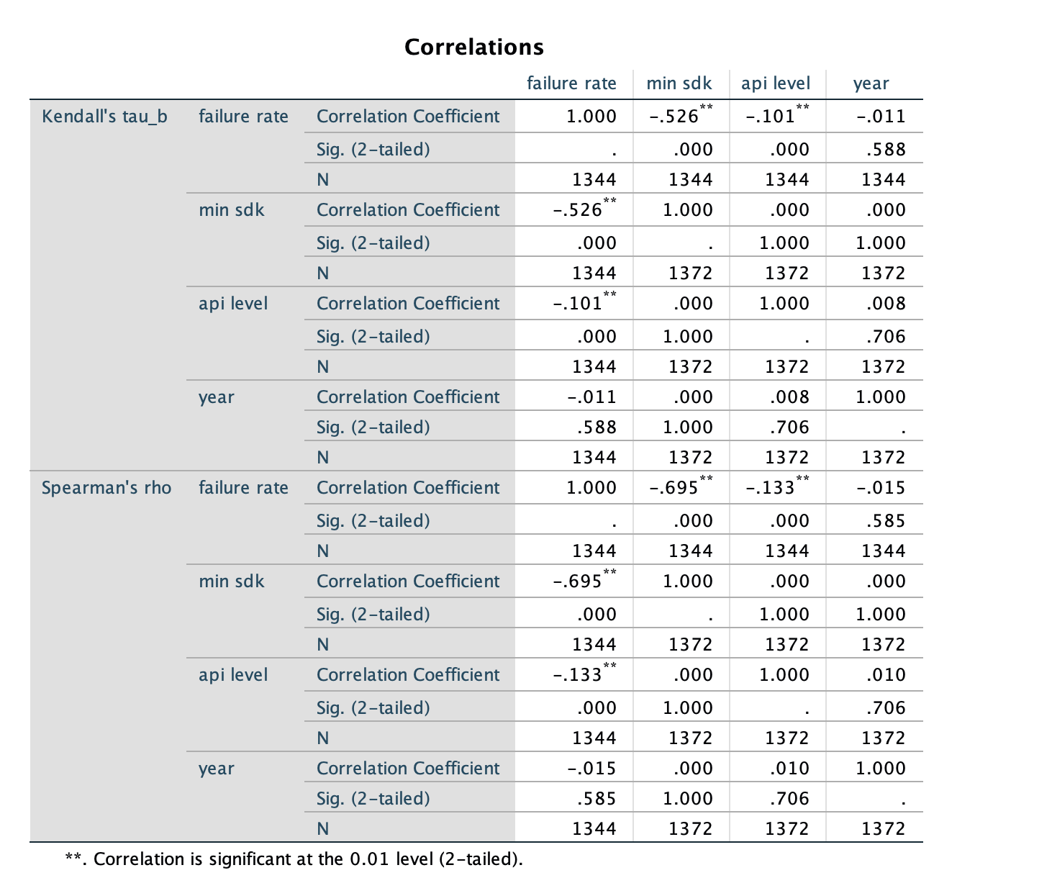
    - INSTALL_FAILED_MISSING_SHARED_LIBRARY
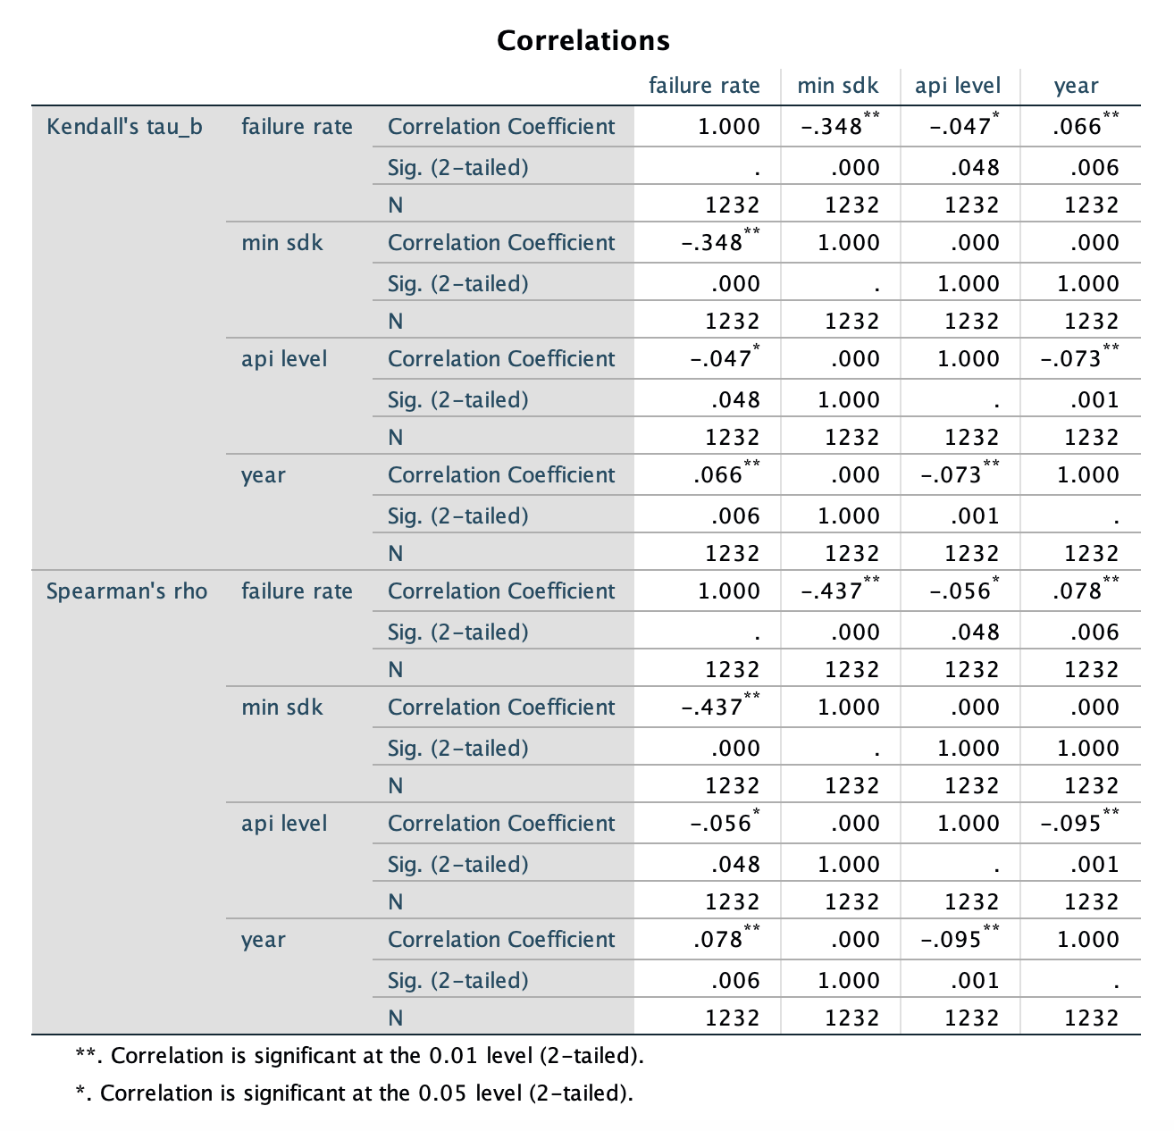
6. Percentage distribution of failure causes
- All (except 27)
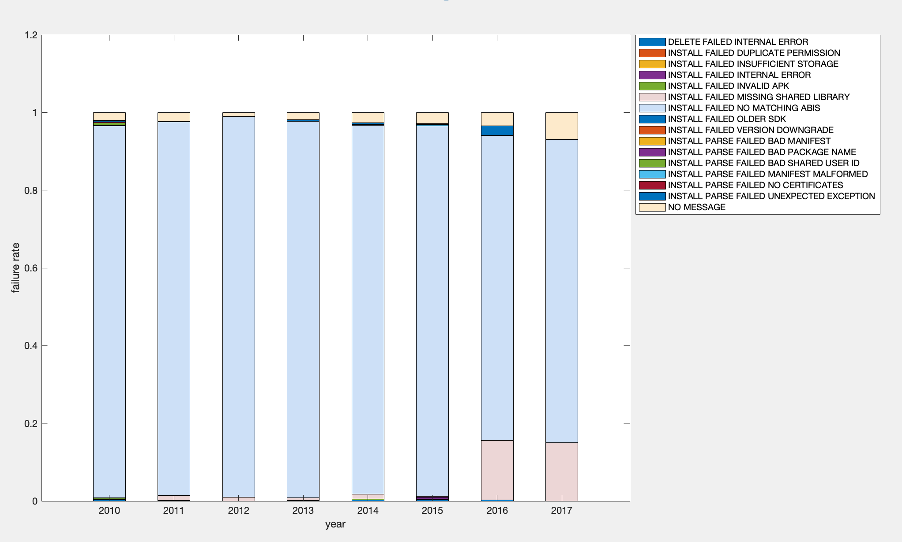
- 27
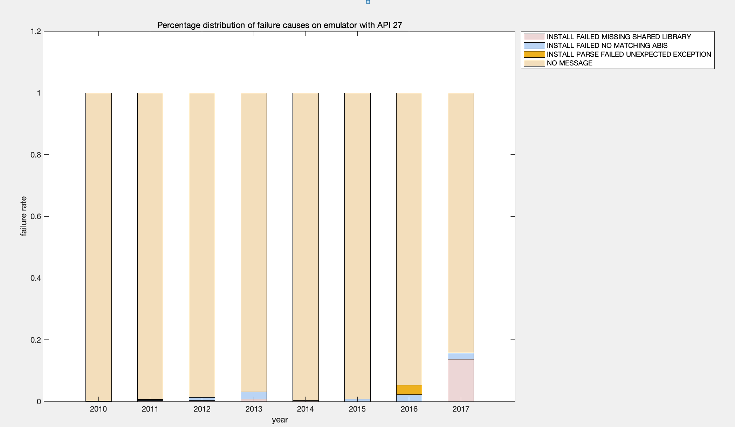

- 26
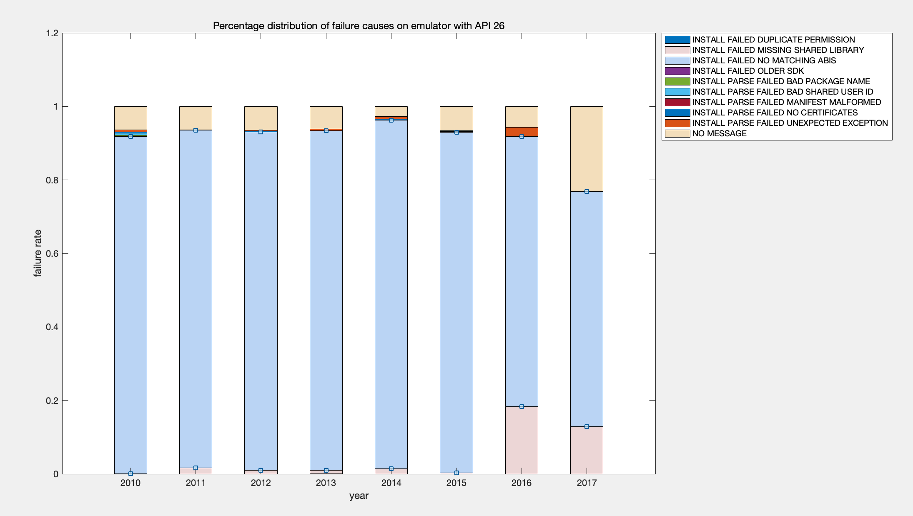
- 25
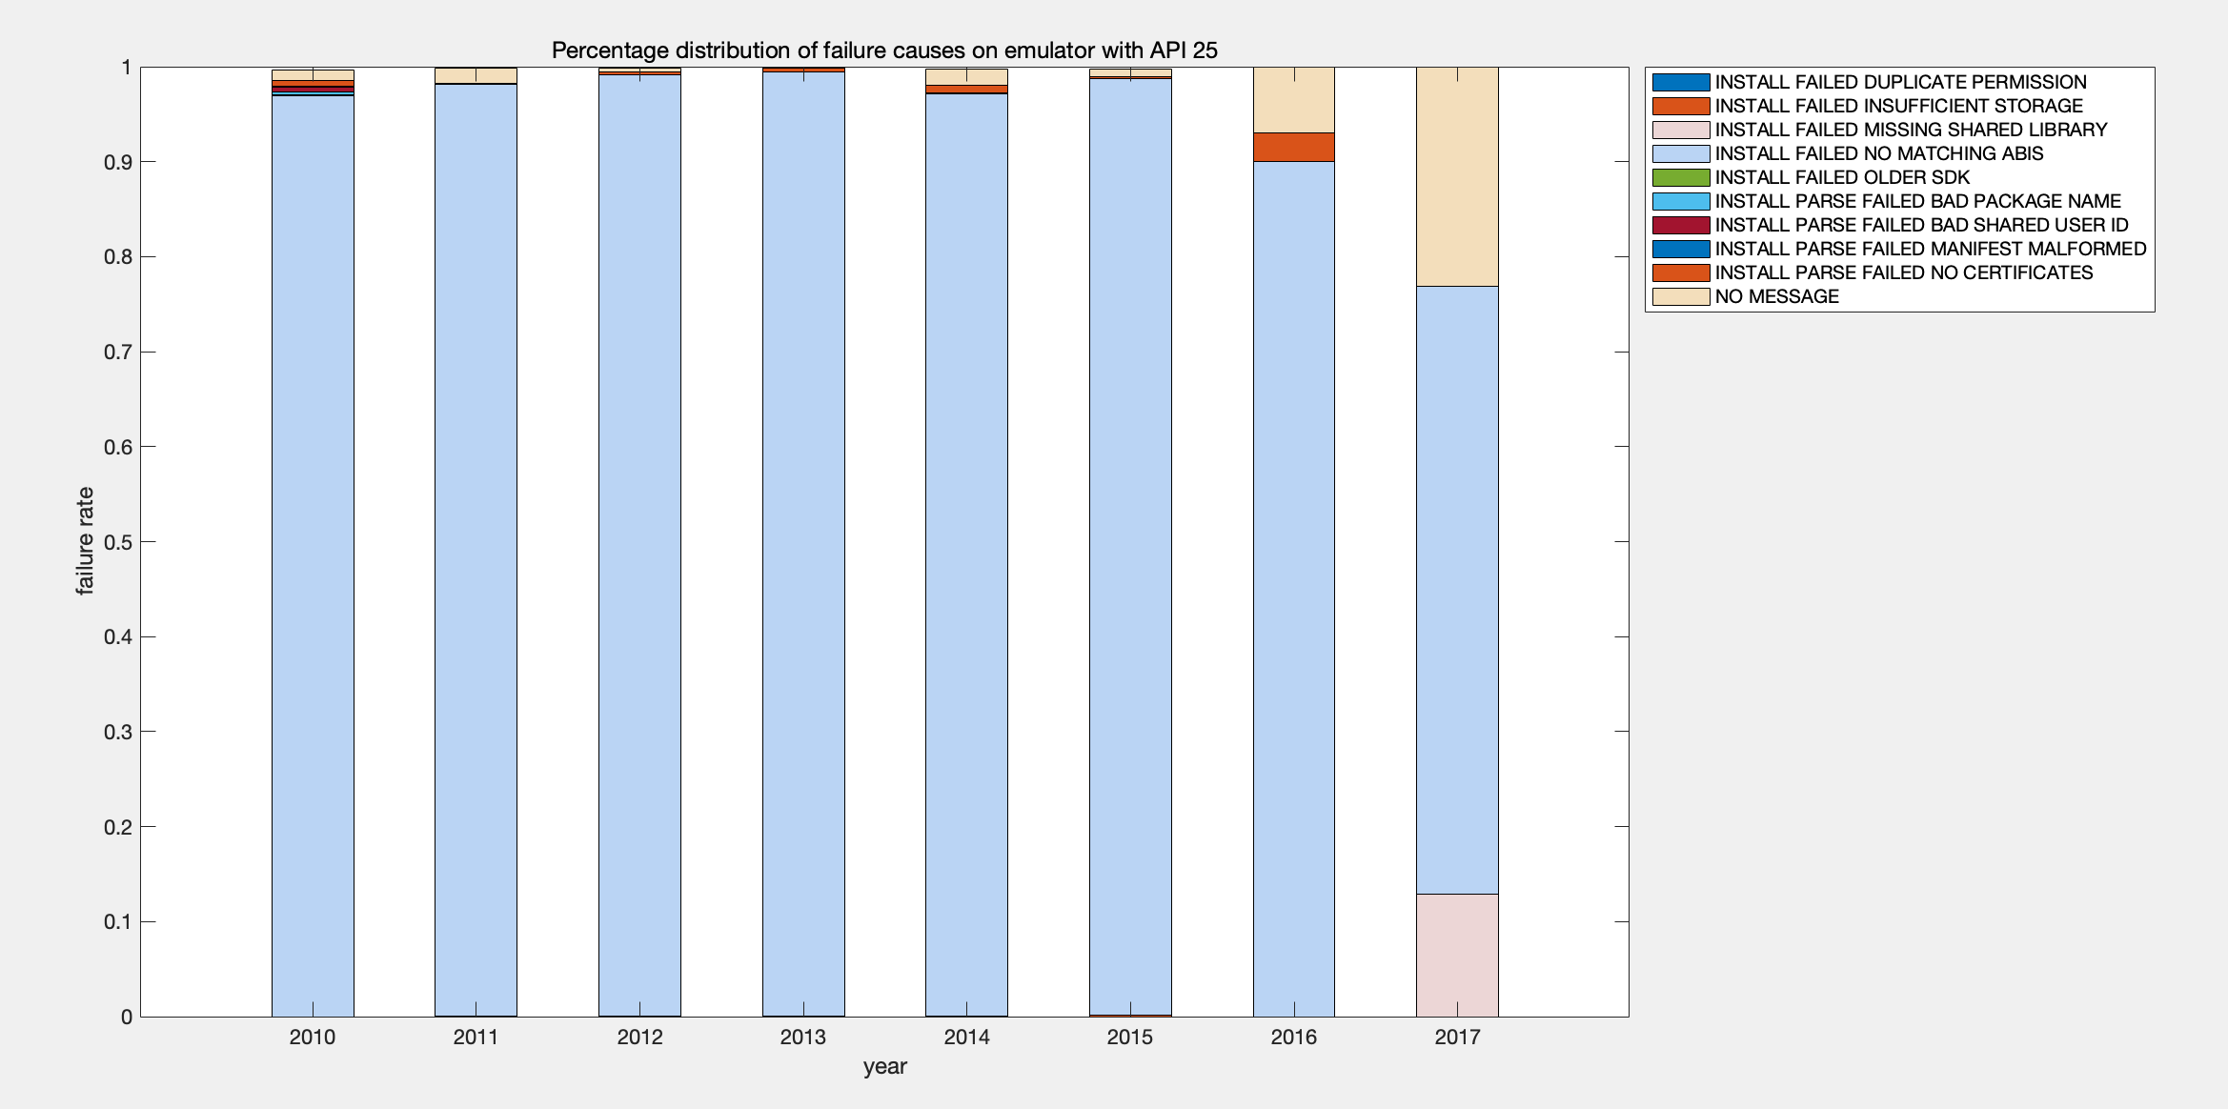
- 24
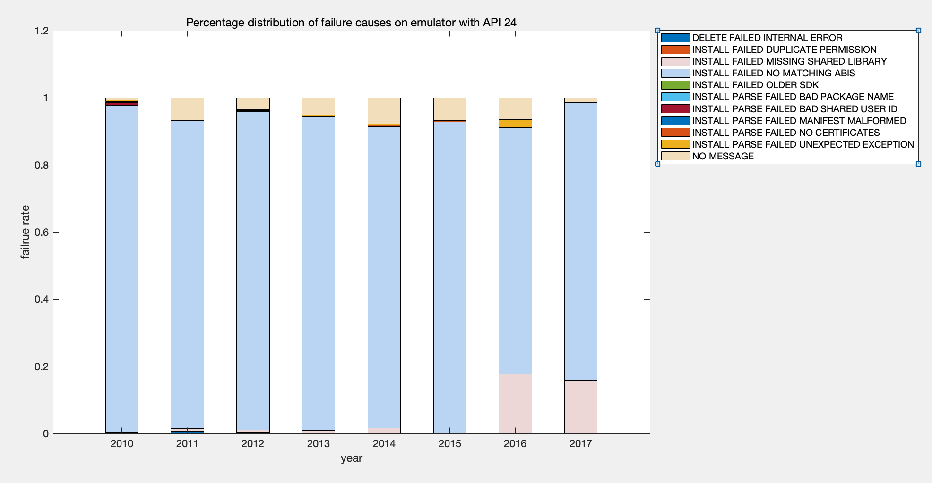
- 23
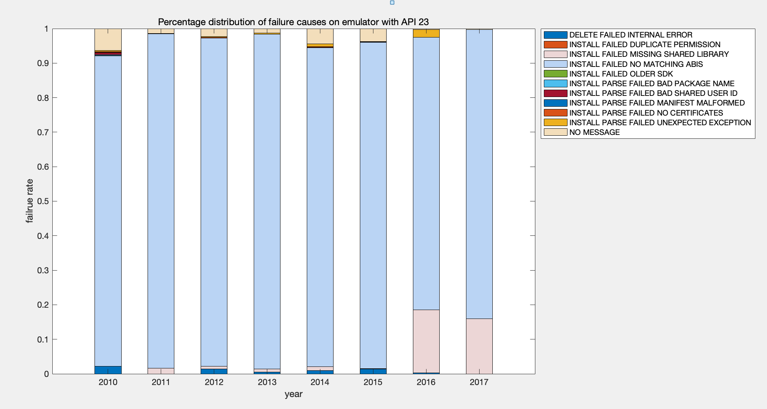
- 22
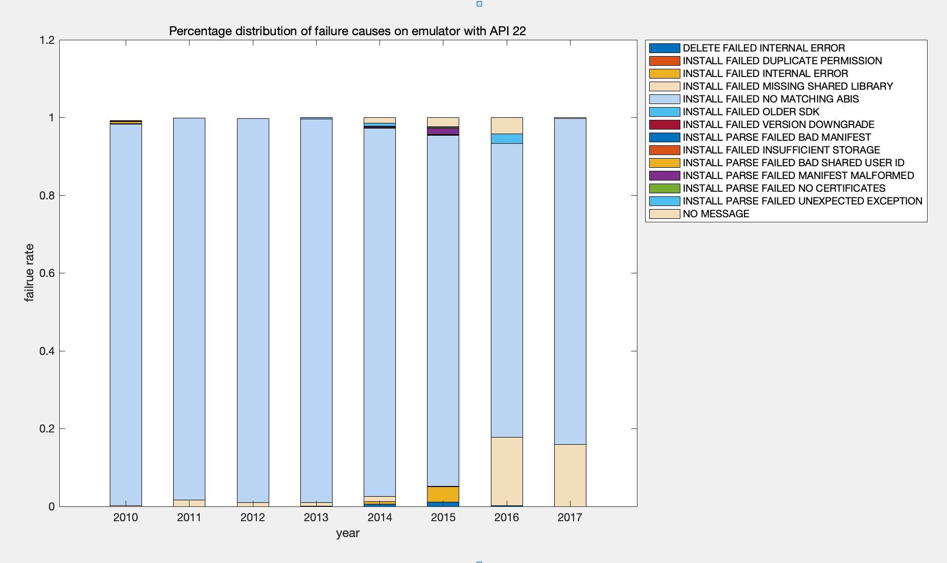
- 21
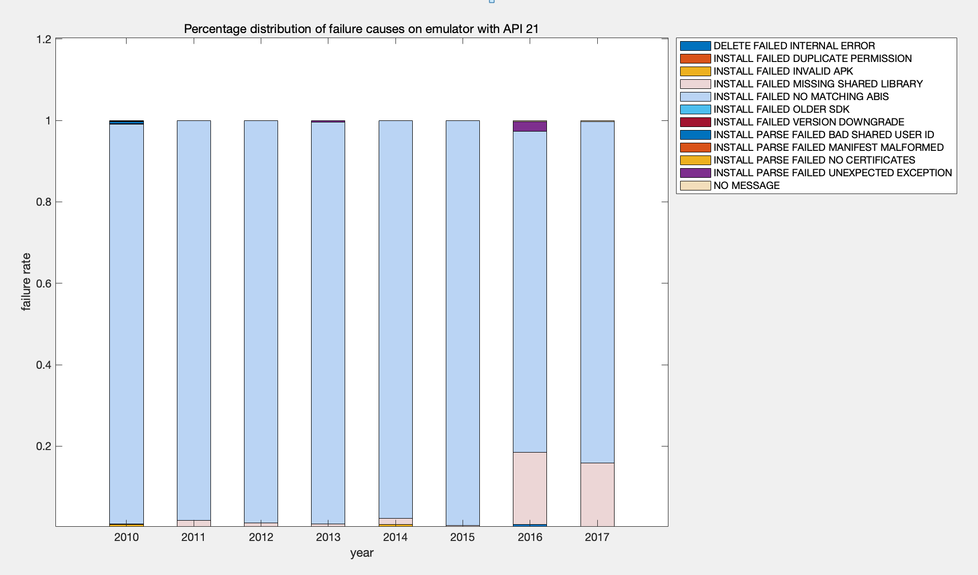
- 19
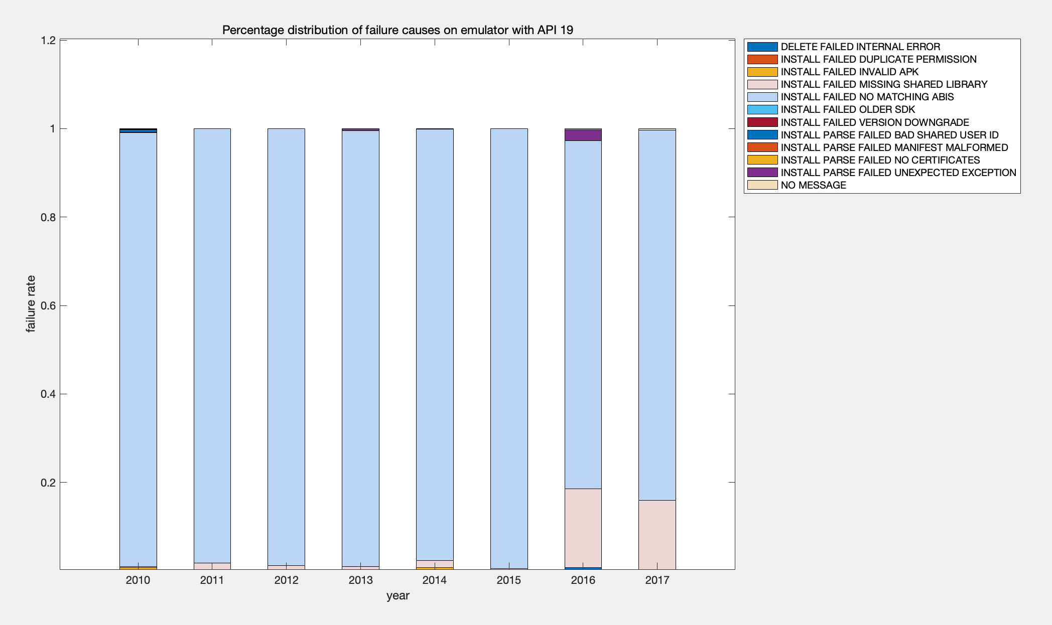

Reference for Spearman's rank correlation coefficient:
- https://en.wikipedia.org/wiki/Spearman%27s_rank_correlation_coefficient
- http://www.statstutor.ac.uk/resources/uploaded/spearmans.pdf

